Jack Nicklaus -Sensation versus Reality
Photos from Golf Digest December 1983

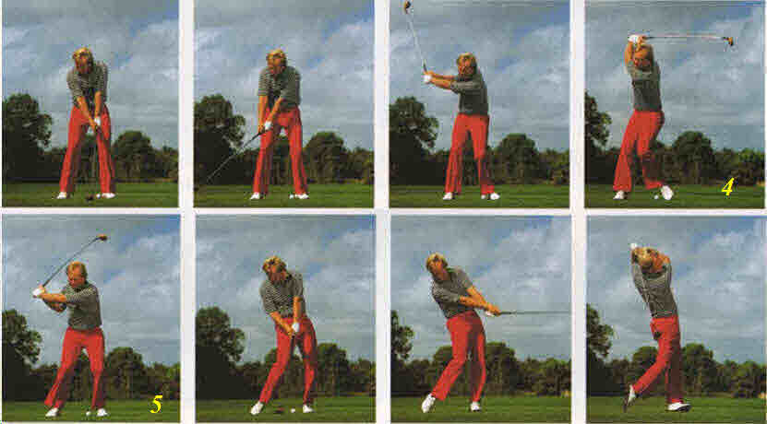
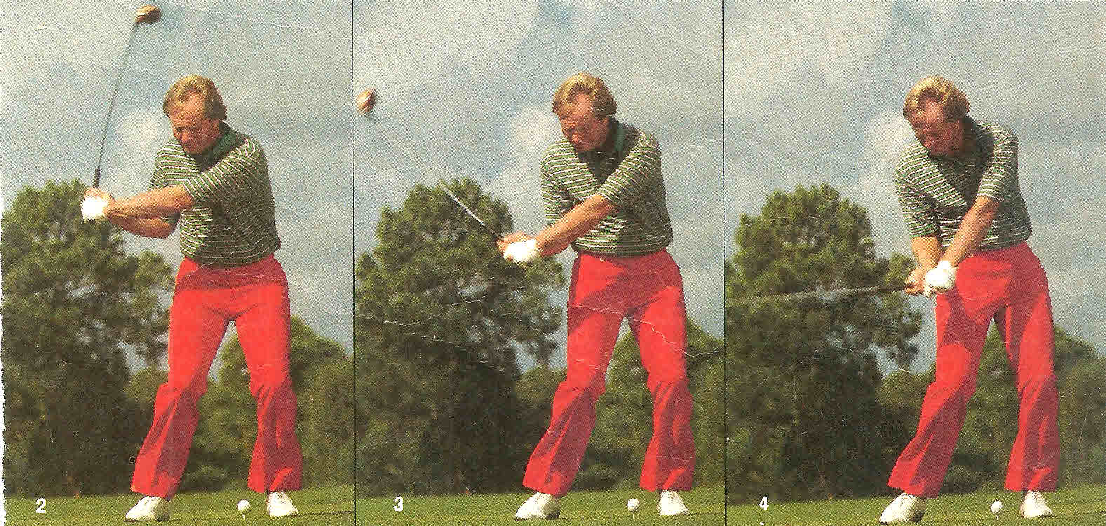
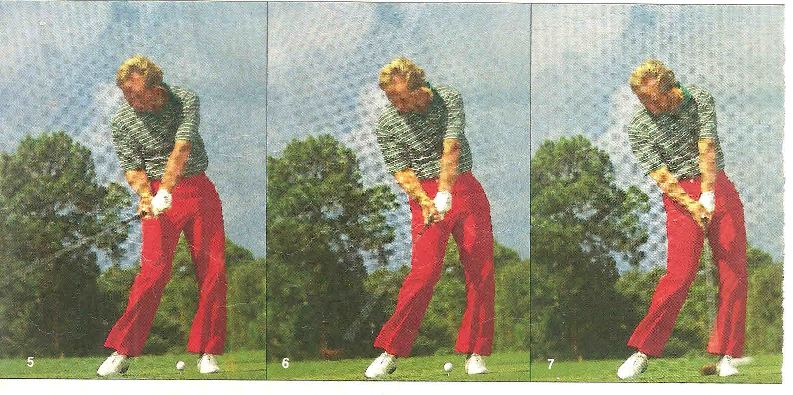
HOW TO PULL THE CLUB DOWN SO IT PULLS YOU THROUGH
By Jack Nicklaus (Golf Digest July 1984 – The full swing in photos: 27)

As I've stressed so often in this series, my forward swing, properly executed, happens reactively in response to my preswing preparation and backswing. For that reason, it's not easy for me to describe in mechanical terms.
However, there is a need here to try to paint some kind of sensory picture of what actually takes place from top to impact and beyond. I believe I might best achieve that by focusing on one simple word. The word is "pull."
At the completion of the backswing, my left heel has been pulled well clear of the ground on the longer shots, and on the shorter ones I'm pulled at least onto the inner edge of my left foot. In either case, my initial move starting down is to firmly replant the left heel, I hope in exactly the same position it occupied at address.
The immediate result of this aggressive replanting of the left foot is a chain reaction, which I'll now try to describe as though I were consciously feeling each move in super slow motion.
As I replant the left heel, it pulls my left knee back toward the target, which pulls my right knee in toward the target, which pulls my hips around toward the "target, which pull my torso, which pulls my shoulders, which pulls my arms, which pulls my hands, which pull the club-shift, which pulls the clubhead.
These are the sensations and the sequence of motions I believe I would experience if I could perform the first half of the downswing slowly enough to feel precisely what was happening, and in what order. As the action progressed farther into the downswing, however, and particularly since my 1980 swing modifications, the feelings would change. Here's how.
Originating always from the ground up, the chain-reaction pulling motion I've just described rises higher and higher through my body as it grows progressively stronger and stronger. In doing so, it creates an ever-increasing amount of centrifugal force in the head of the club.
Centrifugal force is the power that pulls an object outward from its center of rotation. As the centrifugal force in the clubhead increases, it at first gradually and then ever more rapidly reverses the forces being exerted on my hands and wrists. Whereas they began to get into the act simply by pulling down on the shaft of the club in response to all the other pulling motion going on below, now the hands and wrists must increasingly respond to the pulling power of the centrifugal force acting on the clubhead.
The stronger this centrifugal pull, the more my wrists must unhinge. But, for that to happen, the less my hands and arms can continue to pull the shaft toward the target. This causes the hands and arms as a unit to eventually slow down their motion toward the target in direct proportion to the increasing speed of the clubhead.
As the hands and arms slow down, so the pulling toward the target of the body must also diminish to keep the two in step. Eventually, as the wrists unhinge completely in delivering the clubhead to the ball, the body ceases its targetward pulling almost entirely in order to let the hands and clubhead catch up with it completely and to become a firm brace for the hit.
Finally, as the hands totally release the clubhead through the ball and the clubhead begins to rise, it becomes the new pulling force; drawing the body completely around toward the target and the arms high above the head into a free and full follow-through.

The start down comes from the ground up
The first move starting down is the replanting of the left heel, which starts a chain reaction upward through the body—it pulls the left knee toward the target, which pulls the right knee toward the target, which pulls the hips around and in turn the torso, shoulders, arms, hands and club.

The club pulls you on the follow-through
As the hands release the clubhead through impact, the swinging force of the club then begins to do the pulling, drawing the hands, arms and finally the body toward the target, sweeping the hands high above the head into a full, free follow-through.

NEUROSCIENCE INFORMATION

Neuroscience explains how the brain initiates and controls motion:
- The brain performs "acts" with specific outcomes.
- The subconscious mind initiates and controls all voluntary movement.
- The sections of the brain that control movement do not communicate the details to the conscious mind.
Armed with this information, the following statements can be made:
- What you feel and what everyone else feels is not what is happening
- The subconscious is a non-communicating dictator.
  - It never communicates to the conscious mind the details of movements.
- The majority of theories of the golf swing are incorrect because they are based on sensations.

The only thing great players, in any sport, can express is their sensations!

THE CHANCES OF THEIR ANSWERS BEING ACCURATE IS CLOSE TO ZERO!

Jack Kuykendall’s analysis of Nicklaus’ Sensations

In a July 1984 Golf Digest Article, Jack Nicklaus states the following about his sensations during the downswing.

Nicklaus: As I've stressed so often in this series, my forward swing, properly executed, happens reactively in response to my preswing preparation and backswing.
(JK: This is correct. "act" with specific outcomes are performed by the movement control modules of the brain)

Nicklaus: For this reason, it's not easy for me to describe in mechanical terms.
(JK: In fact, it is virtually impossible for someone not trained in scientific observation.)

Nicklaus: I believe I might achieve that by focusing on one simple word. The word is "pull." The start down comes from the ground up. The first move starting down is the replanting of the left heel, which starts a chain reaction upward through the body-it pulls the left knee toward the target, which pulls the right knee toward the target, which pulls the hips around and in turn the torso, shoulders, arms hands and club.
(JK: I want you to take a backstroke similar to Jack Nicklaus' and do nothing but straighten your left leg to replace your left heel on the ground. Do not move any other part of your body. You will immediately know that this is not the first thing that happens in Jack Nicklaus' downstroke. For the body to move from right to left, muscles on the right side of the body must contract (they are the right hip muscles driving the body to the left).

Nicklaus: Nicklaus now states that his left knee can pull his right knee around.
(JK: I would like for anyone to show me how your left knee can pull your right knee to the left. There are no muscles that can contract on the left side of your body and move your body to the left. In all golf strokes, RIGHT SIDE MUSCLES CONTRACT AND DRIVE THE BODY TO THE LEFT.)

Nicklaus: These are the sensations and sequence of motions I believe I would experience if I could perform the first half of the downswing slowly enough to feel precisely what was happening, and in what order.
(JK: This is 100% correct! These are Nicklaus' sensations. They are NOT reality.)

Nicklaus: Originating always from the ground up, the chain-reaction pulling motion I've described rises higher and higher through my body as it grows progressively stronger and stronger. In doing so, it creates an ever-increasing amount of centrifugal force in the head of the club. Centrifugal force is the power that pulls an object outward from its center of rotation.
(JK: All physic books state that centrifugal force is a fictitious force and does not exist!)
Nicklaus’ Actual Mechanics

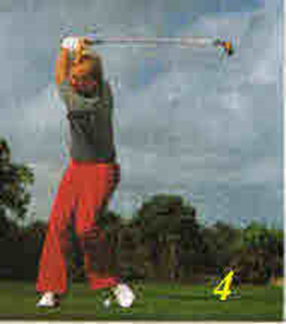 | 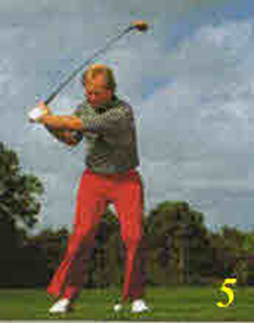
From the top of his backstroke (yellow 4), his right hip muscles contract and drives his body to the left (yellow 5). He sets into his knees. His back is still faced away from the target line. There is virtually no change in the relationship of his arms to his shoulders.
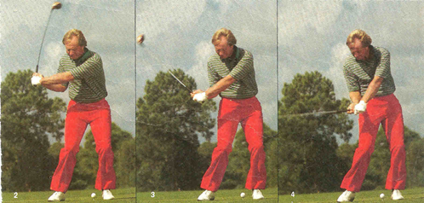 | 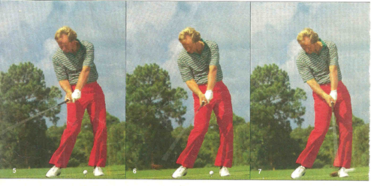
Because his grip is a 2-axis 4-lever right arm system, his body must move upward and backward from the left photo to impact in order not to drive the clubhead into the ground.
Observe that from the left photo to the impact photo, the majority of the motion is produced by the right triceps straightening the right forearm and the muscles of the right forearm and the stretch reflex of the right wrist driving the shaft in line with the right shoulder.
The left hand fulcrum being on top produces virtually none of the clubhead speed. It is only the trailing right hand fulcrum that supplies the speed.
Centrifugal force is a factious force that does not exit and therefore, cannot produce clubhead speed.

SCIENCE EXPLAINS – SENSATIONS MISLEAD

