TIPS - Why Tips Have To Fail
Tips have a 24 hour expiration date!

Golf Publications has found that golfers will pay for a quick fix TIPS.
Neuroscience shows that the brain does not work on TIPS. The brain has no mechanism for establishing a new neuronal circuit from a TIP. If you were a member of my web site you could go to the neuroscience section and have a correct scientific understanding why TIPS fail.
Without knowing any neuroscience, you can reason for yourself that TIPS always fails. The magazine covers below are a sample of some yearly titles. They will have, on a yearly basis, at least one cover on the following:
SLICING: How to cure your slice
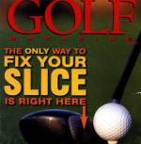 | 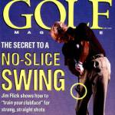

POWER ARTICLES: How to hit the ball farther

TIPS: Quick fix TIPS and how not to choke.
The average score for male golfer has been around 100 for the past 100 years. No TIP has worked. The majority of amateurs are slicers with distances far below their potential. If TIPS could work, the statistics would have changed. They have not!

There is one way and one way only. You must change your brain patterns.
There are no short cuts. You must follow three steps.

- The first is knowledge. Purchasing the Neuroscience and Mechanics Section of the Scientific Knowledge section is the starting place.
- The second step is to use training aids that forces you to change your mechanics. Our training aids have helped thousands of golfers improve their mechanics.
  - You cannot watch videos and succeed.
  - You cannot read about mechanics and succeed.
  - The brain establishes effective new neuronal patterns ONLY when YOUR body passes through correct position on a weekly basis.
  - It is virtually impossible to make the changes without training aids. YOUR BRAIN only wants to do the patterns you have established. It will hate the new patterns.
- The third step is monitoring. Our video analysis program lets use assist you every step of the way.

