MOTION:

Overview of the brains neuronal connections for mechanical motion
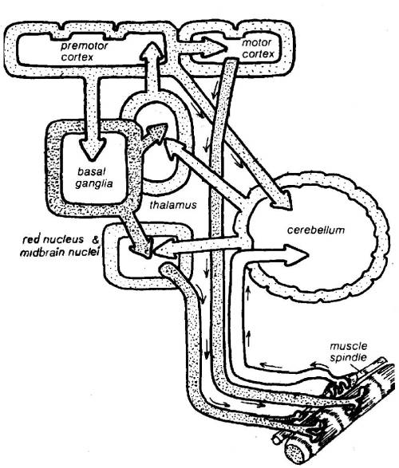
- The basal ganglia programs the timed sequences of contractions for the entire motion that is going to be performed.
- It sends signals to the thalamus (central relay station) and the red nucleus and midbrain nuclei.
- The thalamus sends signals to the premotor cortex.
- The premotor cortex sends signals:
  - back to the basal ganglia,
  - to the motor cortex,
  - and the cerebellum.
- The motor cortex sends a signal to the muscle.
  - The muscle contracts and sends a signal to the cerebellum
- The cerebellum coordinates the movement with the command from the premotor cortex and sends feedback to the thalamus to continue execution of future instructions.
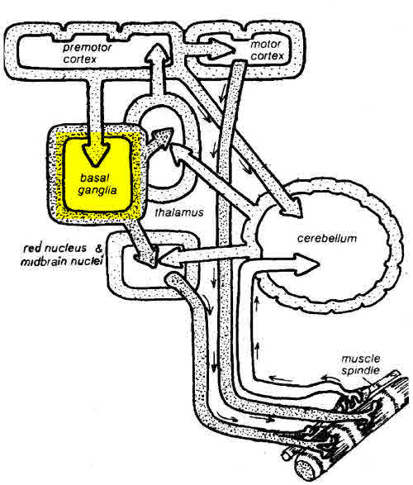 | 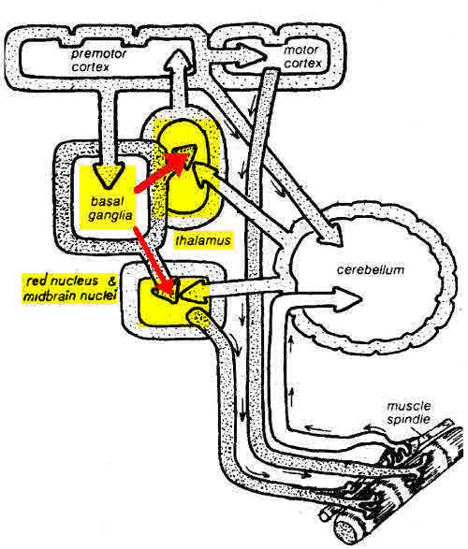
The basal ganglia programs the timed sequences of muscle contractions for the entire motion that is going to be performed | It sends signals to the thalamus (central relay station) and the red nucleus and midbrain nuclei
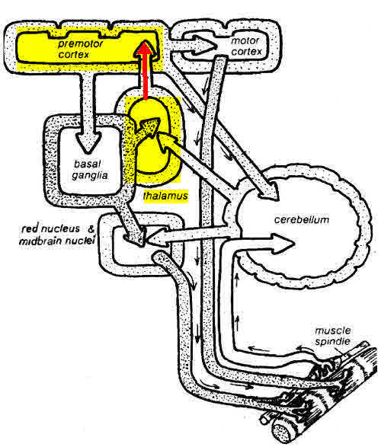 |  | 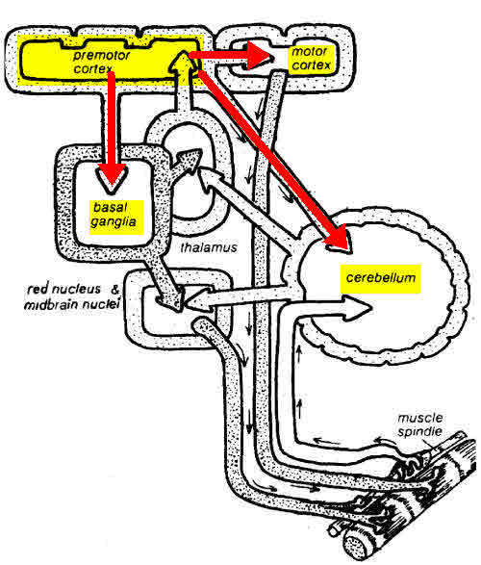
The thalamus sends signals to the premotor cortex. |  | The premotor cortex sends signals:  back to the basal ganglia, to the motor cortex, and the cerebellum.
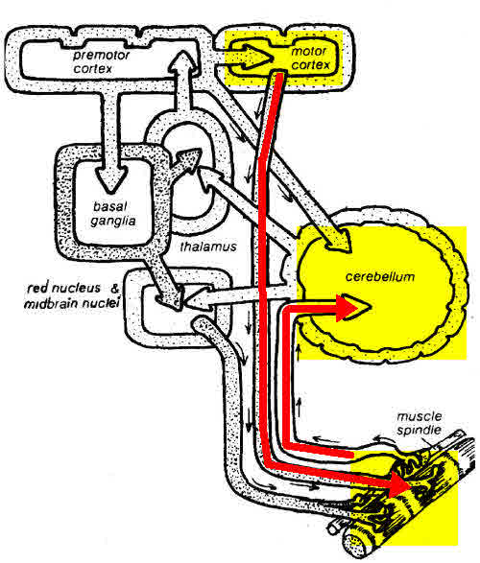 |  |  | 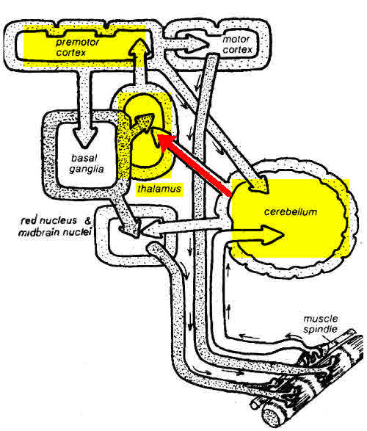
The motor cortex sends a signal to the muscle. The muscle contracts and sends a signal to the cerebellum |  |  | The cerebellum coordinates the movement with the commands from the premotor cortex and sends feedback to the thalamus to continue execution of future instructions
The brain is performing billions of these signals simultaneously and keeping up with all of them. All of this is controlled by the subconscious with extremely limited feedback to the conscious mind. What you FEEL consciously is not what is happening.

