From the March 2008 issue of Scientific America, the following article provided more information on the mechanical skill reproduction and age.
The title of the article was White Matter Matters.

Story at a Glance:
- To reach world-class athletic skills, an individual must start young.
  - In pianists, those that start before age 11 are superior to those that start in their teens. A critical age period exist for superior skill acquisition.
- An impulse typically takes 30 milliseconds to travel from one cerebral hemisphere to the other through myelinated axons in the corpus callosum, compared with 150 to 300 milliseconds through unmyelinated axons.
  - This means that when you learn at an early age while the myelinated sheaths are developing around the axons, the impulses are 5 to 10 times faster in coordinating motion.
- Of course, Old geezers can still learn, but they are engaged in a different kind of learning involving the synapses directly.

WHITE MATTER: Although scientists have long regarded the brain's white matter as passive infrastructure, new work shows that it actively affects learning and mental illness • • • By R. Douglas Fields

Imagine if we could peek through the skull to see what makes one brain smarter than another. Or to discover whether hidden traits might be driving a person's schizophrenia or dyslexia. A new kind of imaging technique is helping scientists observe such evidence, and it is revealing a surprise: intelligence, and a variety of mental syndromes, may be influenced by tracts within the brain made exclusively of white matter.
Gray matter, the stuff between your ears your teachers chided you about, is where mental computation takes place and memories are stored. This cortex is the 'topsoil" of the brain; it is composed of densely packed neuronal cell bodies—the decision-making parts of nerve cells, or neurons. Underneath it, however, is a bedrock of "white master" that fills nearly half of the human brain—a far larger percentage than found in the brains of other animals. White matter in composed of millions of communications cables, each one containing a long, individual wire, or axon, coated with a white, fatty substance called myelin. Like the trunk lines that connect telephones in different parts of a country, this white cabling connects neurons in one region of the brain with those in other regions.
For decades neuroscientists exhibited little interest in white matter. They considered the myelin robe mere insulation and the cables inside it little more than passive passageways. Theories about learning, memory and psychiatric disorders centered on molecular action inside the neurons and at the famous synapses—the tiny contact points between them. But scientists are now realizing that we have underestimated the importance of white master in the proper transfer of information among brain regions. New studies show that the extent of white matter varies in people who have different mental experiences or who have certain dysfunctions. It also changes within one person's brain as he or she learns or practices a skill such as playing the piano. Even though the neurons in gray matter execute mental and physical activities, the functioning of white matter may be just as critical to how people master mental and social skills, as well as to why it is hard for old dogs to learn new tricks.

More with Mastery: The myelin that gives white matter its color has always posed mysteries. For more than a century scientists looked at neurons through their microscopes and saw long fibers, the axons, extending from a neuronal cell body to a neighboring one, like an outstretched, elongated finger. Each axon was found to be coated with a thick crystalline gel. Anatomists surmised that the fatty covering mast insulate axons like rubber sheathing along a copper wire. Strangely, however, many axons, especially the smaller filaments, were not coated at all. And even along insulated fibers, gaps in the insulation appeared every millimeter or so. The bare spots came to be known as nodes of Ranvier, after French anatomist Louis-Antoine Ranvier, who first described them.
Modern investigation has revealed that nerve impulses race down axons on the order of 100 times faster when they are coated with myelin-

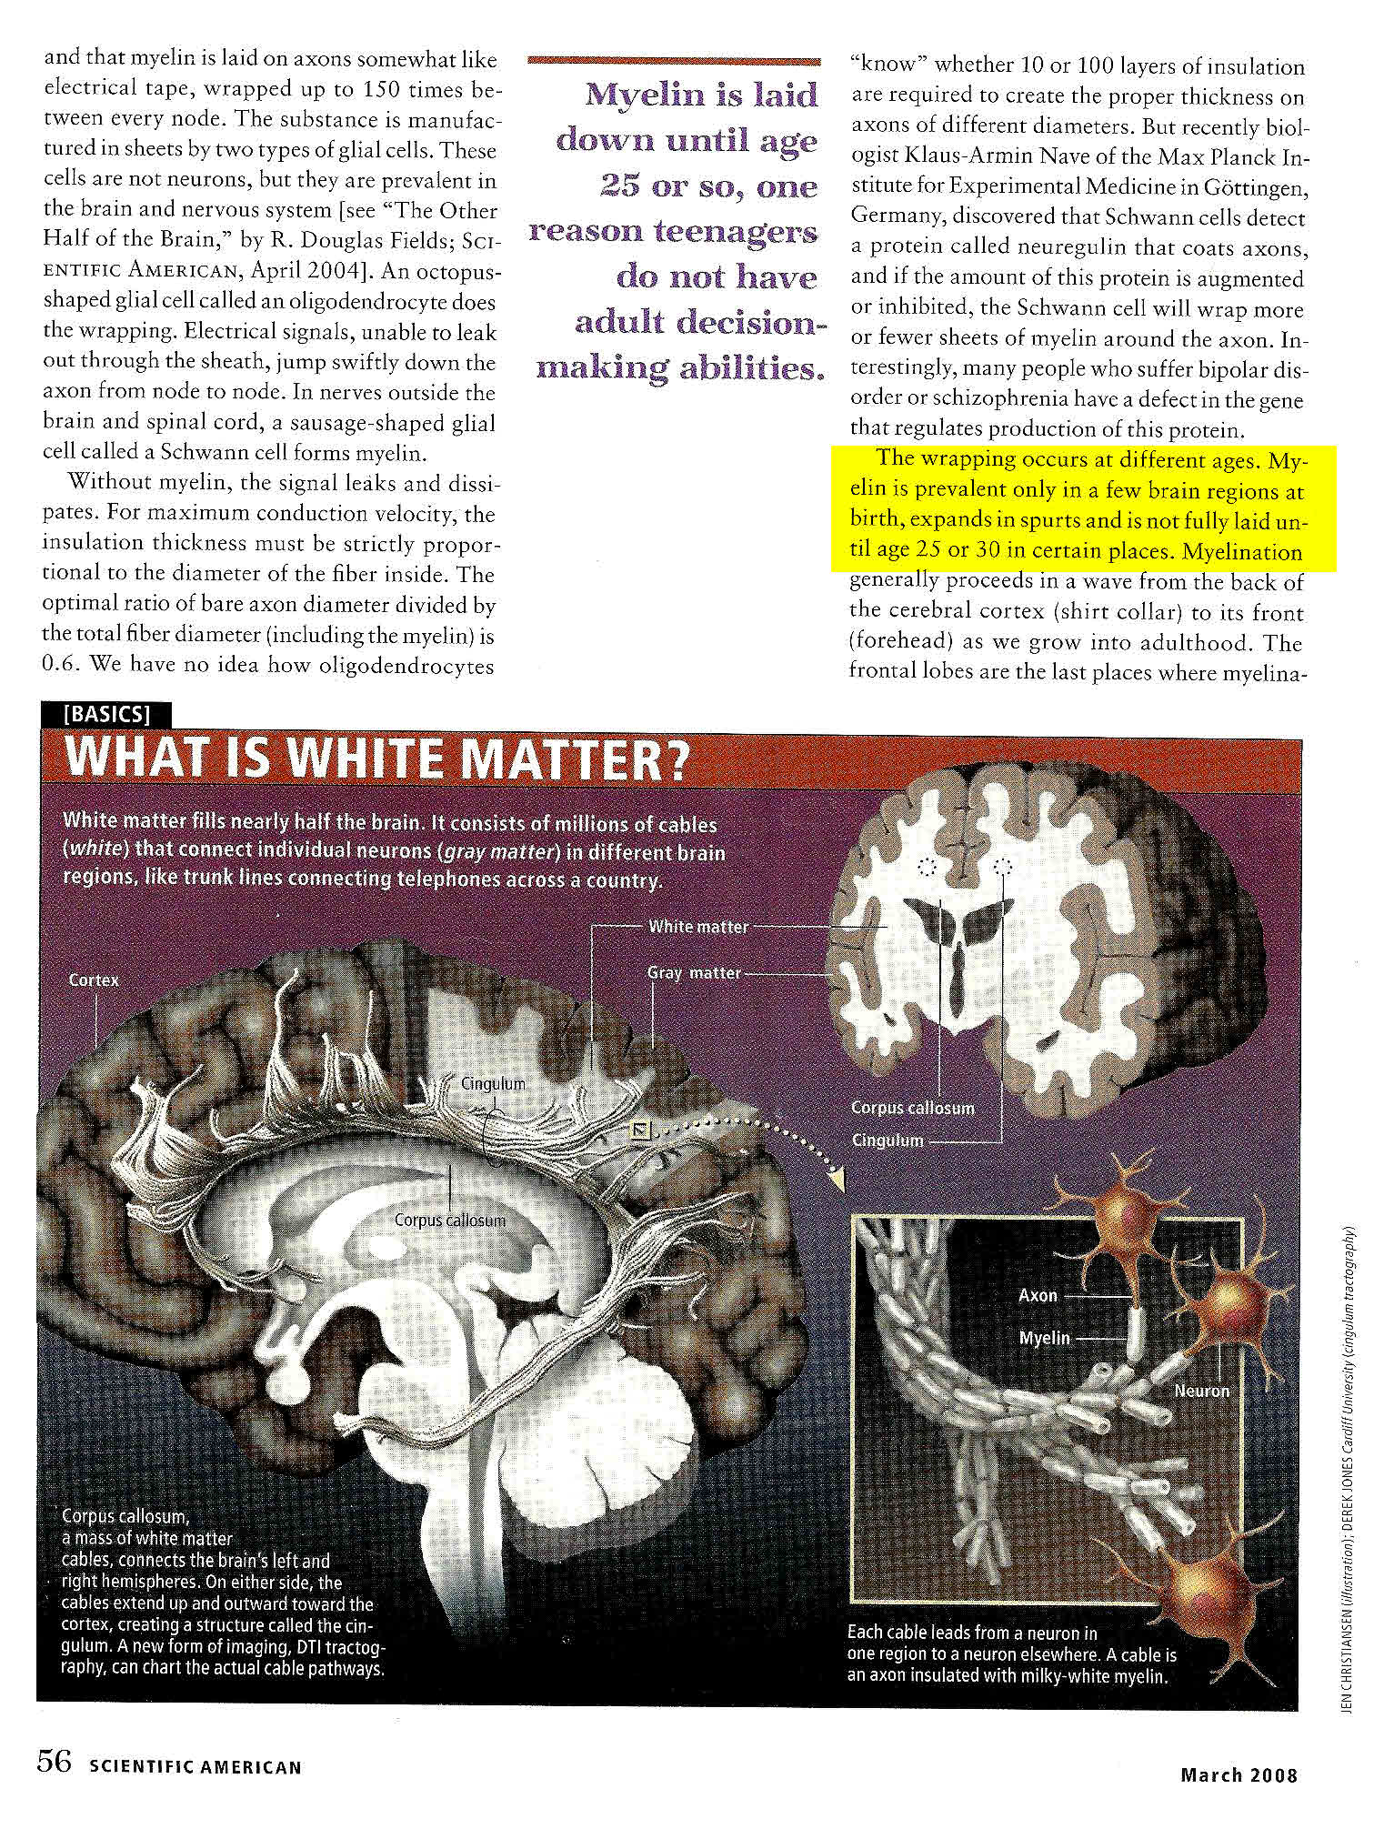

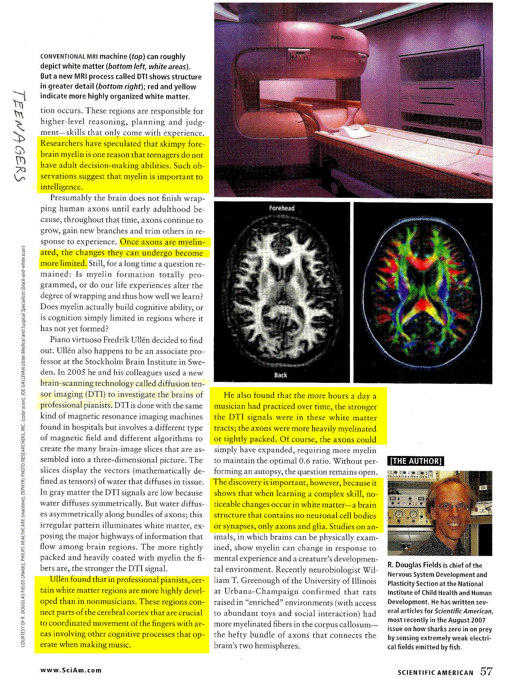
TEENAGERS

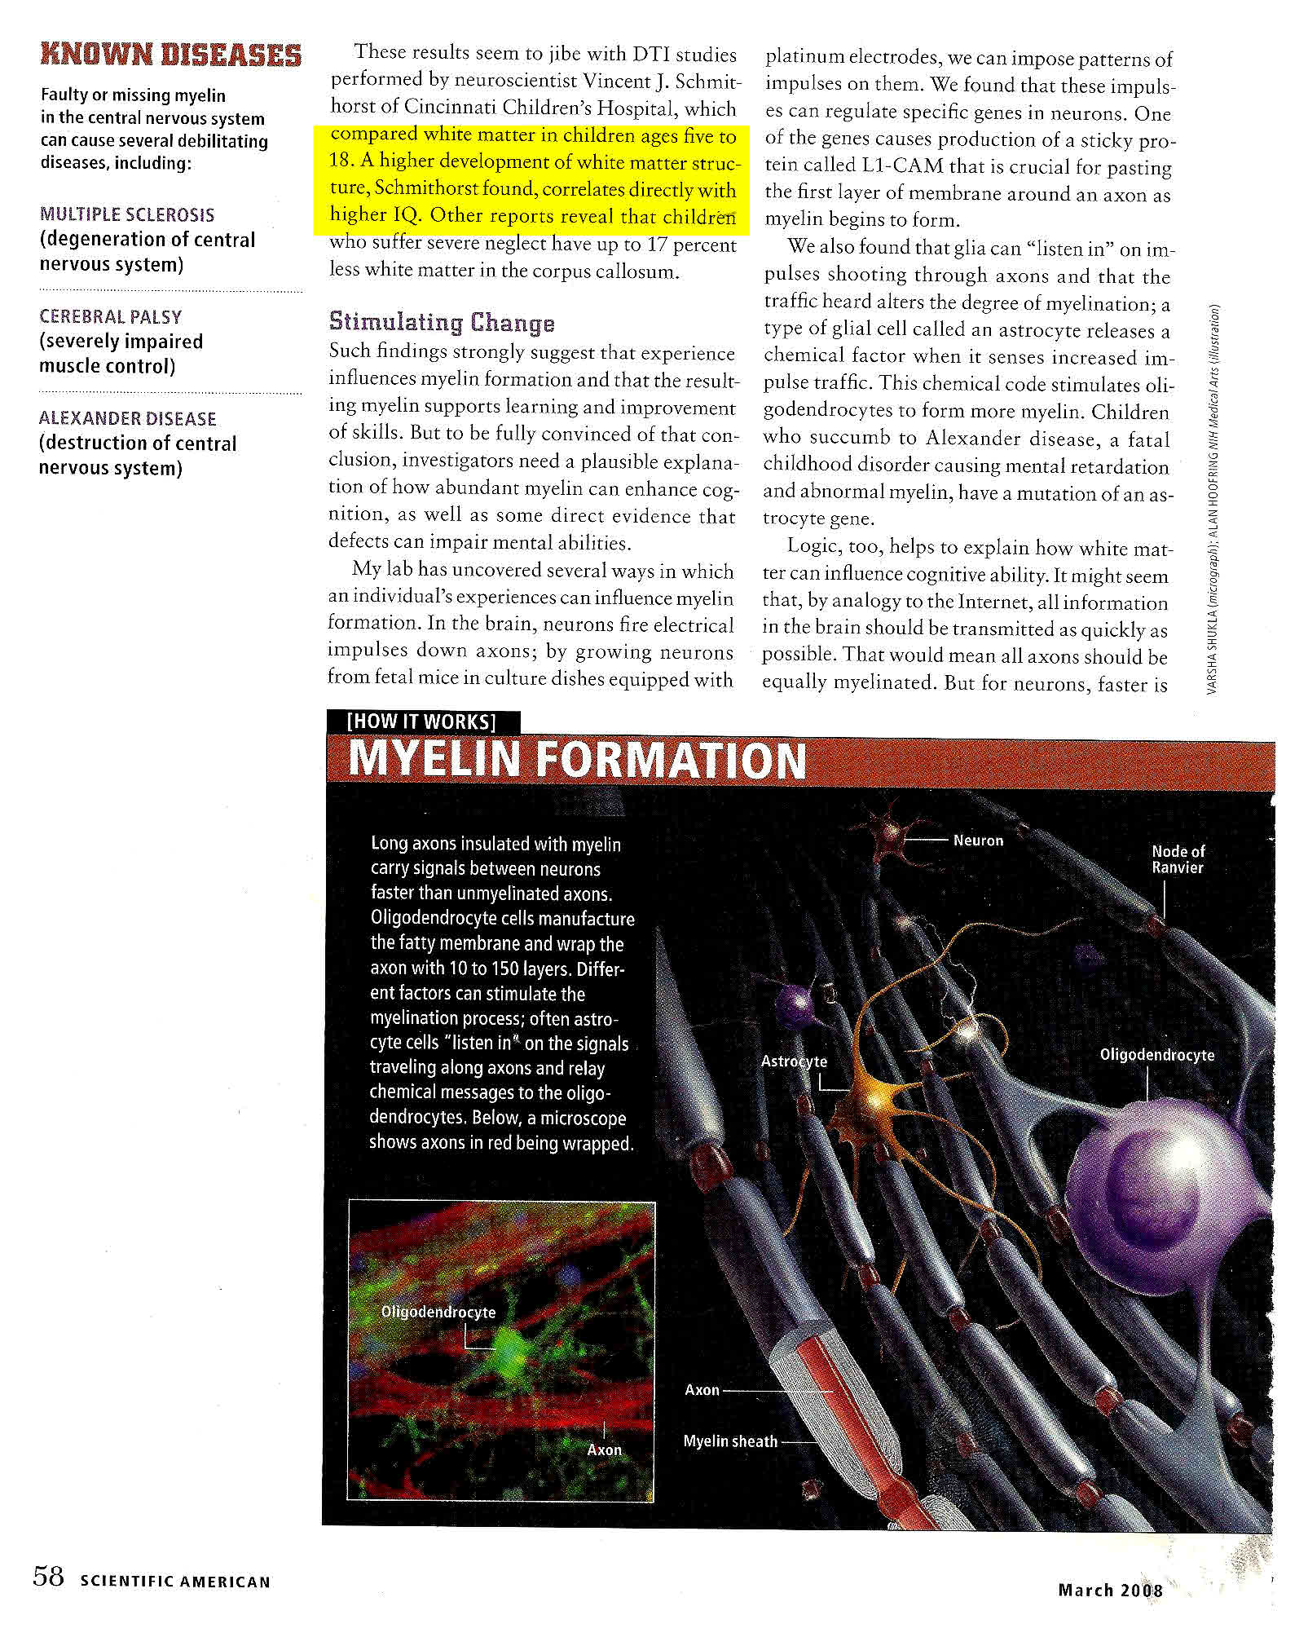

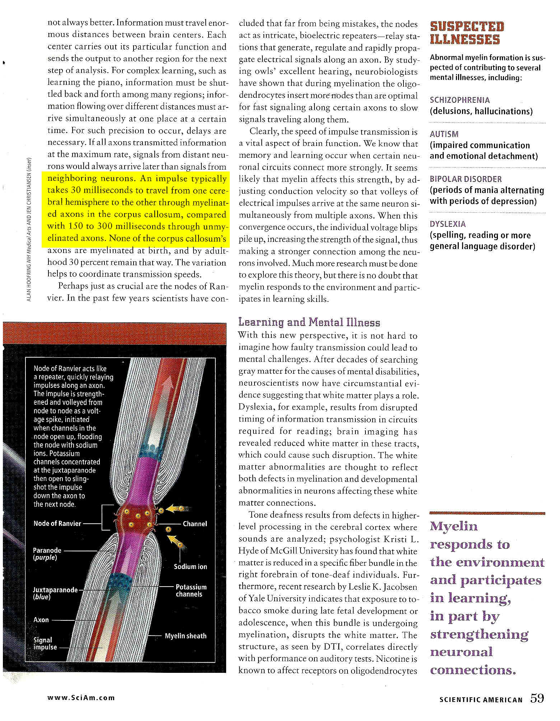

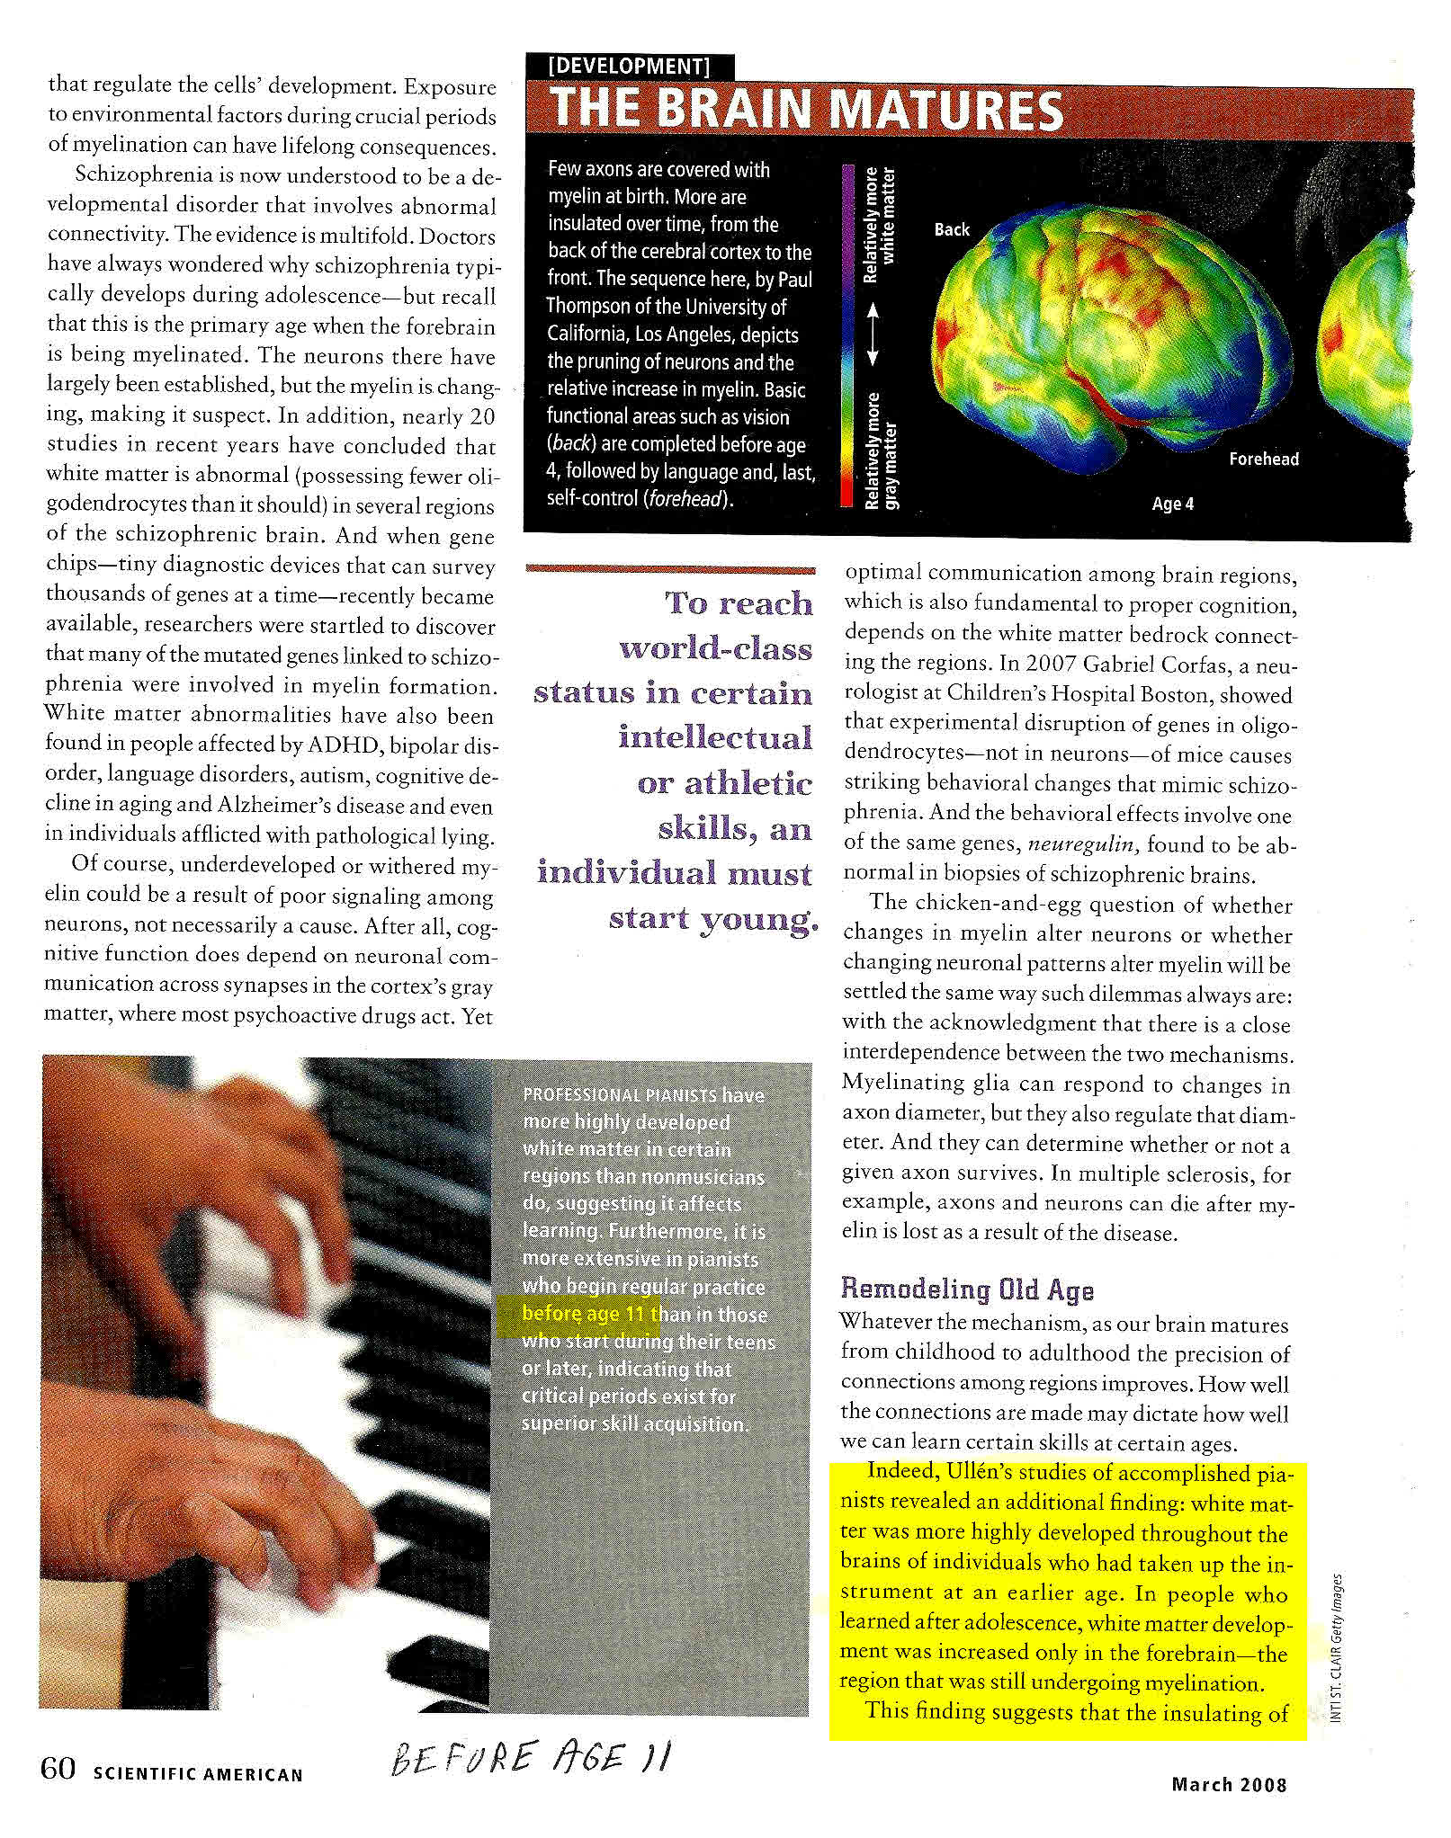
Before Age 11

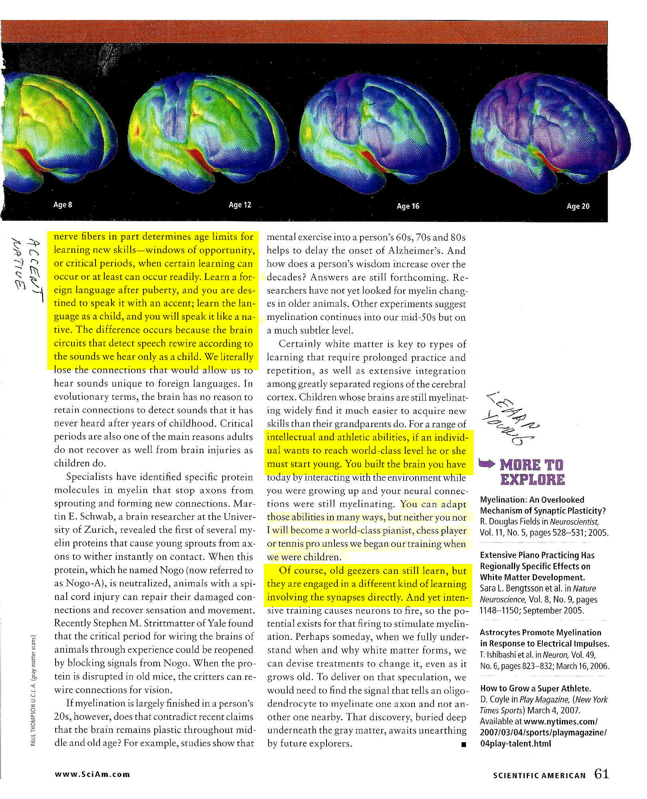
OLD GEEZERS CAN STILL LEARN

