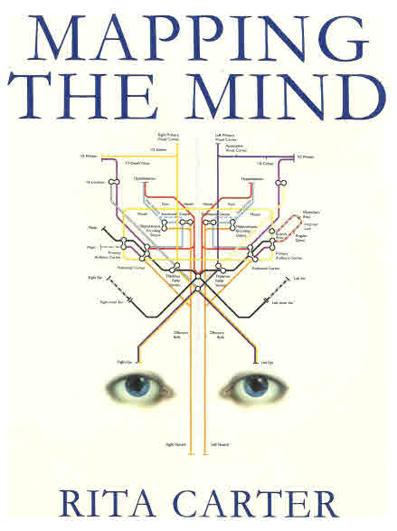
Mapping The Mind by Rita Carter
(Pages 22&23): We cannot remember things before the age of about three because until the hippocampus - the brain nucleus that lays down conscious long term memories - is not mature.
(Page 57): The putamen's (part of the basal ganglia) function is to look after automatic movements - those that have been learned by repetition.
(Page 159): Memories form when a pattern is repeated frequently, or in circumstances that encourage it to be encoded. This is because each time a group of neurons fires together, the tendency to do so again is increased. This process is called long-term potentiation. If the neighbor cell is not stimulated again it will stay in this state of readiness for hours, maybe days.
(Page 164): Episodes that are destined for long-term memory are not lodged there straight away. The process of laying them down permanently takes up to TWO YEARS. Until then they are quite fragile and may quite easily be wiped out!
(Page 162): Experiences which are destined to be laid down as long-term memories are shunted down to the hippocampus where they are held in storage for 2-3 years. During this time the hippocampus replays the experiences back up to the cortex, and each rehearsal etches it deeper into the cortex. Eventually the memories are so firmly established in the cortex that the hippocampus is no longer needed for their retrieval.
(Page 162): Much of the hippocampal replay is thought to happen during sleep. Dreams consist partly of a rerun of things that happened during the day, fired up to the cortex by the hippocampus.
(Page 162): PROCEDURAL MEMORY the 'how to' sort of like riding a bike, are stored in the cerebellum and putamen. The brain has 100 trillion connections joining billions of neurons and each neuron and each junction has the potential to be part of a memory.
(Page 175): So the memory capacity of a human is effectively infinite, providing it is stored in the right way. (page 175).

Jack Kuykendall Comments:

What does this mean for the golf stroke? If you have not established these connections in the subconscious motion circuits, YOU CAN'T PERFORM EFFECTIVELY! THERE ARE NO CIRCUITS!

You can't effectively perform a mechanical motion that does not exist in your subconscious motion circuits. When you take a lesson, it's very difficult to impossible to perform a high speed motion that you have never performed before. There are NO established circuits. It takes numerous repetitions performed correctly to acquire effective and reproducible circuits.
The old saying of "What you arrived with is what you play with" is scientifically true. It's virtually impossible to improve your golf stroke by making a change during a round. The person giving the advice may mean well but you'll always play worse during the round. To think about stroke mechanics requires the conscious mind, and the conscious mind contains NO motion circuits.

What these statements mean for the golf stroke is that you must perform the mechanical motions you want to execute a minimum of twice a week for up to two years before they become automatic.

