LONG DRIVING
Increasing your launch angle and decreasing your spin rate will help you hit it farther.
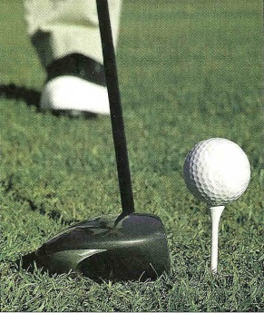
- Use a lower lofted club; this reduces spin.
- Tee the ball forward in your stance;
  - Launch angle increases due to ball impact on the upswing.
- Tee the ball higher;
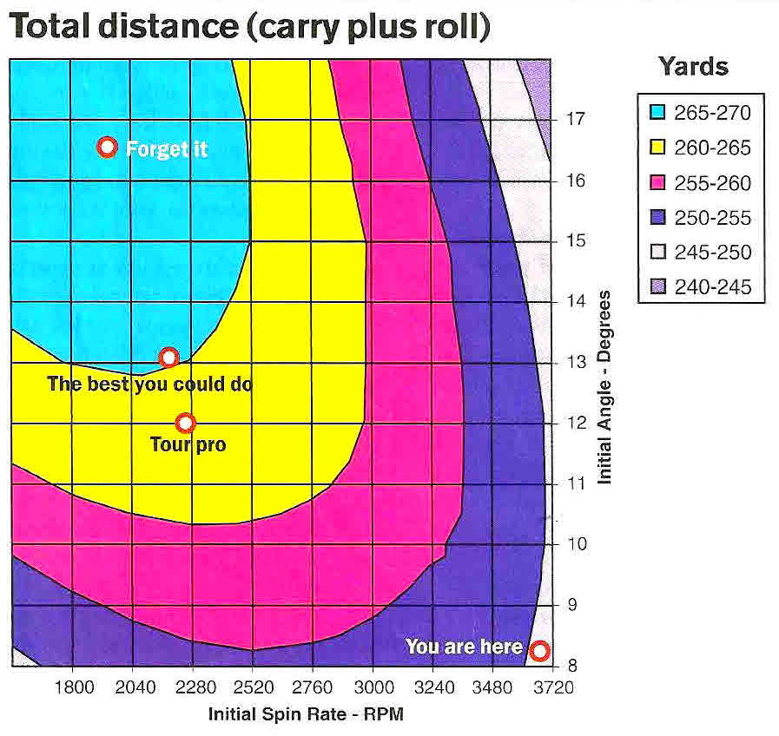
  - Launch angle increases due to impact on an extreme upswing.
Moe Norman has the lowest spin rate Golf Digest has ever seen. It was 1,500 rpm. Moe’s clubhead speed at age 66 was100 mph and his air carry was around 250 yards. His launch angle was 18 degrees. The average amateur, with over 3,000 rpm of backspin will air carry between 220 and 230 yards.

You can achieve your maximum air carry with this information

