WET MIND by Stephen M Kosslyn & Oliver Koenig

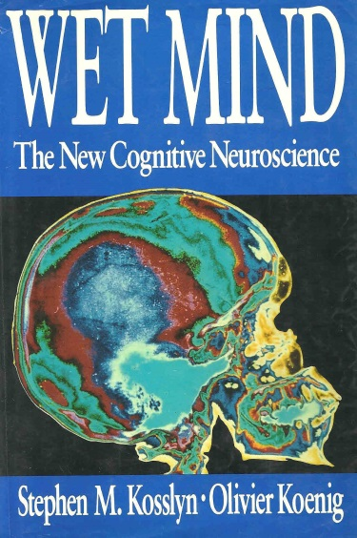
How does the brain control movement? According to Stephen Kosslyn's and Oliver Koenig's book, WET MIND, the brain performs four actions to initiate and control movement. They are:
- ACTION PROGRAMMING,
- INSTRUCTION GENERATION,
- MOVEMENT EXECUTION
- MOVEMENT MONITORING

INSTRUCTION GENERATION: receives the program from the ACTION PROGRAM; storing and computing a sequence of instructions for a brief period before and while they are executed.
MOVEMENT EXECUTION: activates and controls the muscles that produce the movements - executing, not planning.
MOVEMENT MONITORING: engages in learning and trajectory computation. In the learning phase, it acquires a model of the joint angles, their angular velocities, and the corresponding motor commands. Movement monitoring determines the trajectory that requires the smallest changes in torque. A movement command is entered that corresponds to the one specifying the present position of the limb, and the estimated position of the limb compared to the desired target position. The deviation between the estimated position and the target position is then used to send a correction signal backwards. The proper movement commands are those discovered by movement monitoring in the course of computing the trajectories. The error-correction feedback led movement monitoring to minimize the torque and develop the smoothness performance index. Experiencing torque during a golf stroke is the signal that you are performing the stroke non-optimally.
Humans can inhibit movement rapidly. Only about 90 milliseconds are needed to inhibit a task (60 milliseconds from appearance, 30 milliseconds to inhibit).

Jack Kuykendall’s Comments: An easy example to identify is a checked swing in baseball. In the golf stroke, the feedback system is constantly verifying the position of each joint and muscular contraction and making adjustments during the stroke to allow the clubhead to reach the target, the ball.
The above explanation of how the brain functions explains why there are no secret moves in golf. The brain programs millions of instructions and carries them out according to a set plan.
No one movement can ever make a golf stroke effective. A single incorrect movement can make a golf stroke ineffective. NO SECRETS exist in the brain. Stop looking for a secret. There are none.

