Traditional PGA/Tour versus Single-Axis Mechanics

The photos below show five top tour player’s mechanics at:
- Address.
- Six one hundredths of a second before impact.
- Impact.
Every tour player’s address position consists of a four-lever, two-axis right arm mechanical system.
At six one hundredths of a second before impact:
- Knees are substantially bent.
- Back of the left hand pointing skyward.
During the next six one hundredths of a second to impact:
- Left and right leg straighten upward.
- Spine moves upward and backward.
- Hands are substantially higher than they were at address.
- Hands rotate by approximately 90 degrees.
- Major angle between hips and shoulders.
  - Major torque on the back.

If the clubface varies by 1 degree at impact, the ball will not land inside of a 40 yard wide fairway.
Traditional mechanics require extreme coordination to be effective. Tour players work long hour on their timing and tempo.

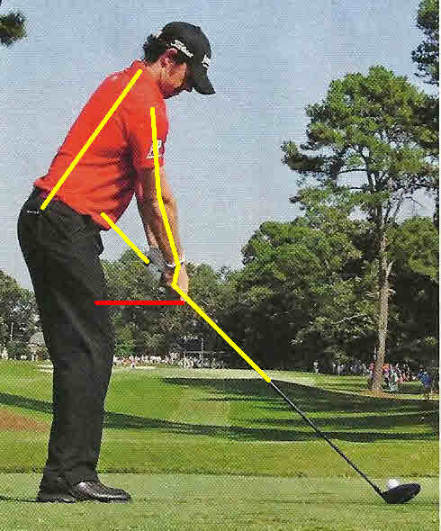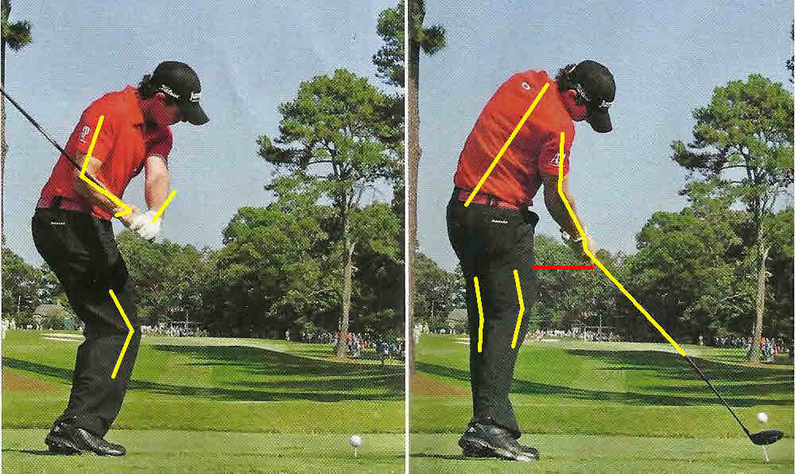Rory McIlory
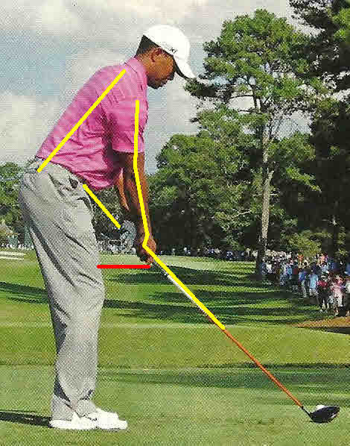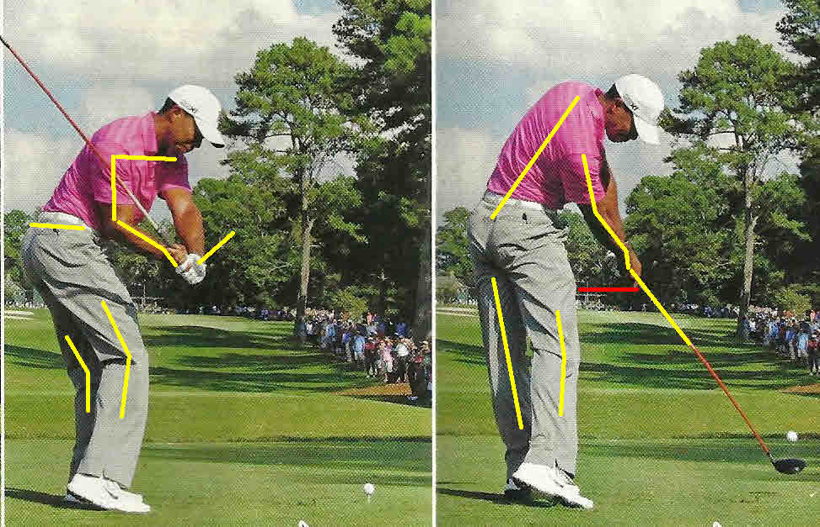Tiger Woods

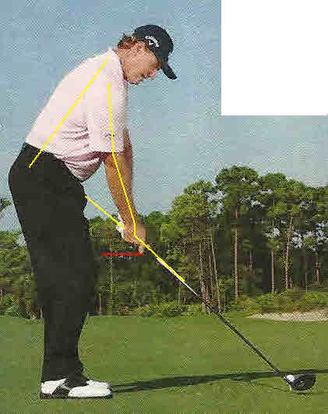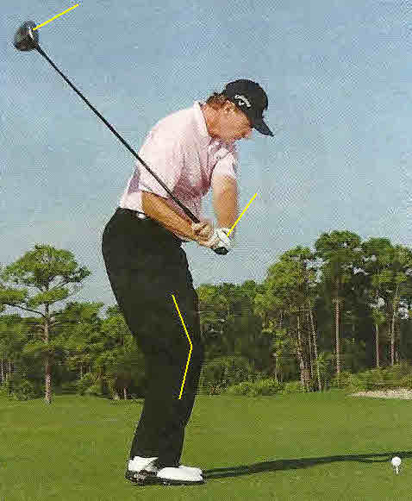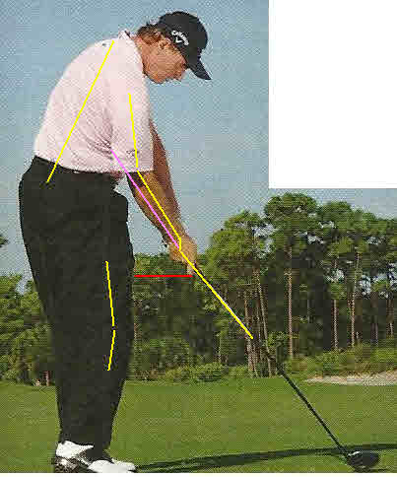
Ernie Els
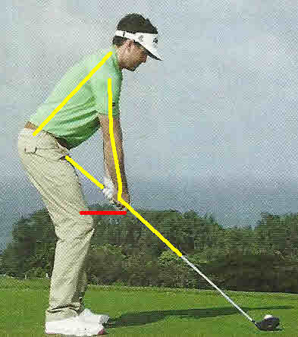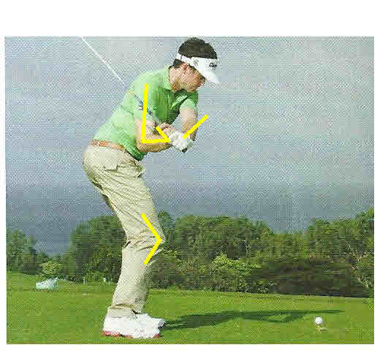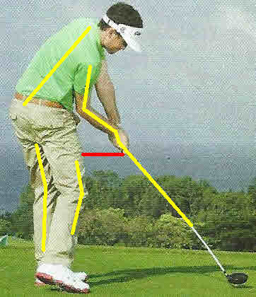
Keegan Bradley

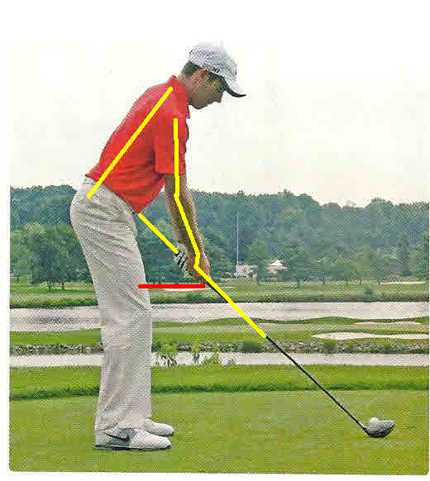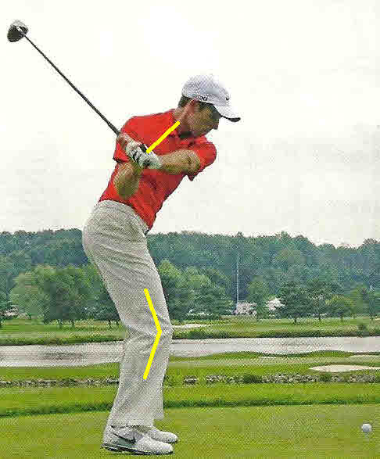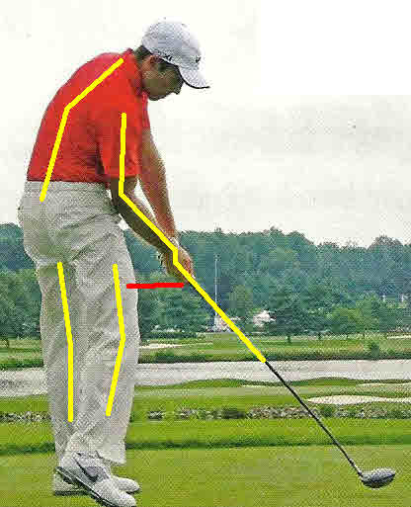
Charl Schwartzel

Why Single-Axis of the right forearm and shaft provide a mechanical advantage; a Moe Norman Style Mechanics

At Address:
- Slight bend in knees.
- Straight line from right shoulder to clubhead.
- Grip in the palm of the right hand; Single-Axis Grip.
At Impact:
- Mass moving in the direction of the force.
- Knees bent more than at address.
- Straight line from clubhead head through right forearm.
- Shoulders, hips, knees facing same direction as address.
- Spine angle remains the same.
